0

# Executive Summary

The very basis of the project is the realisation of a video game, in our case, named “the Commute killer” by informatic students. Engineering economics students, which we are, had the task to plan the whole business part.

This document is the result of an analysis both financial and managerial of the launching of a video game. Based on engineering economics courses and researches, a business plan with its financial projections has been established for the five first years of the company.

The business being part of the large video game area, some assumptions have been made along this work. This game creation will be directly joining the whole market with some existing platforms such as “Steam” which allows advertising and using existing knowledge and communities.

Creating a game requires lots of hours of developing and tools to do it such as computers which can quickly become expensive. That is why some investments and loans have to be made to ensure that the company has time to grow.

We decided to create a social capital of 70k€ with owner’s invested money in addition to a 40k€ loans, all of that described in the sections below.

However, “The commute killer” should allow the company to be stable and financially independent within the five first years. Starting with five staff members to achieve the hiring of two more at the end of the five first years is the main goal which would be the result of a growth.

That will allow the company to grow enough to try other markets such as developing the game on multi-platform, creating new games, in short terms : expand.

# 

**Index**

**Executive Summary** **1**

**Introduction** **3**

**Description of the game** **3**

**Market & Competition** **4**

Market 4

Competition 6

**Commercial & Business strategy** **7**

Addressing the market 7

Business model & source of income 7

Financing 8

**Financial projections & estimation** **8**

Assumptions 8

Required investments 9

Costs estimation 9

Human resources 10

Cash flow estimates 10

Financing KPIs 10

Future of the company 11

**Conclusion** **11**

**Appendix** **13**

# Introduction

The main goal of this project is to simulate a small company as if we were the CEOs of the company. The company is a small one which aims to create and then sell a video game.  
  
We can associate this kind of small enterprise as a startup, which is a trend nowadays. In startups, the wages are limited, the budget is limited, and the staff is limited as there is not any income at the beginning and CEOs/founders often must realize the financial and business planning as we are going to do.

As we were not the designers of the game but informatic students were, we intervened like consultants on the project. We talked about many aspects of the game and the goals with the designers to understand their needs and their goals.

Following their requirements and assumptions, we oriented ourselves in only one market as will be described later, only to expand better afterwards.

The guideline we’ve decided to adopt, was to invest money in elements that will be profitable for sure.   
We managed to implement a business plan within 5 years taking into account the NPV and other crucial factors.

# Description of the game

“The Commute Killer” is a character controlling game where the player will be able to navigate through different locations composed of two main situations (in the character’s office or on the streets).

The game will offer the player an experience composed of strategy and exploration. Indeed, the player has the ability to explore the streets in search of interactions while having some “puzzle” and a need of finding the target that the character is assigned to eliminate.

Finally, there is the elimination step where the player can make things happened within a proper equipment to make the assassination look like an accident. Globally, the game should present these features

* The game has 2 main locations (Character’s Office and the streets);
* On the Office’s wall exists a city map that contains the information discovered and the points of interest from the target’s routine;
* The Main Character possesses a notebook where he annotates the information about the target; It also has some contacts of people capable of some special activities (eg: closing the road for “construction purposes”, obtaining CCTV footage, etc); Asking the contacts for help costs money; More contacts can be found by looking up phone books and searching through people’s possessions;
* Contracts have a deadline (eg: 1 day, 1 week, etc) and some initial information on the target (eg: personal/job addresses, favorite cafe, etc); The amount of information decreases per contract; You may get the wrong person if you’re not careful.
* For each successful hit job the player receives a reward; If it was finished before the time limit the player receives a bonus. However, if the time limit ends then receives a penalty;
* The contracts and the payments are delivered in a secret room at a nondescript location under the guise of a local business (like a tea-house for example);
* There are several ways of observing the target (eg: following by foot, seeing through a telescope, analysing CCTV footage, getting on the subway car next to them etc);
* For the assassination, it is possible to interact with elements on the street (eg: cars, traffic signs, some NPCs, etc) and thus change the environment; It is also possible to leave the Office with some specialized equipment that helps you on the job (eg: night vision goggles, costumes etc);
* Depending on the target, if the assassination does not look like an accident it will arise suspicion.

Thanks to this kind of organization, the game is organized following levels with different difficulties and different maps following the cities countries where the character could intervene. That allows a lot of modularity and the possibilities to expand the game and continuously make it better by adding levels, puzzle, missions, etc.

# Market & Competition

## Market

For the very beginning of the game which consists at least to the first five years of the project, the target is the PC community.

Indeed, thanks to a lot of professional players which use platform such as “Youtube” and “Twitch”, the community is a lot more playing over PC than before : a PC player is often better at a game than a console one with a controller.

Moreover, the market seems to constantly grow and is expected to grow from $27.73 billion in 2018 to $30.71 billion through 2022. *( BUSINESS WIRE – The “PC Games Global Report 2020”).*

However, the market seems to have evolved the same way that games did. As we can see on the following graph (Figure 1), packaging became less important than DLC in terms of proportions.

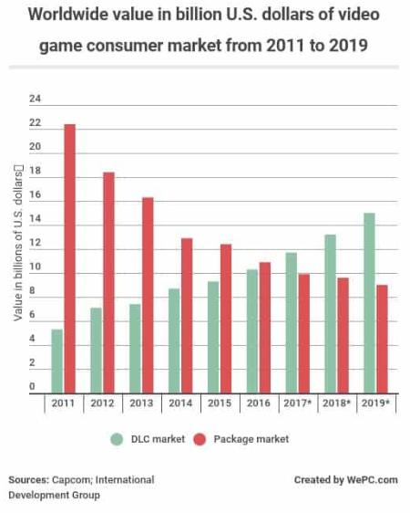

Figure1

The DLC which corresponds to “Downloadable content” is mostly used in the gaming world regarding PC or last generation consoles.  
DLC is additional content that allows player to continue his experience inside the game by obtaining more levels or more gaming mode. The DLC are incredible for players who hate waiting years to get the release of a new game from the same sequel (for example Assassin’s Creed 1, 2, 3…). Moreover, the DLC market allows the developers a continuous revenue with loyal customers.

However, it is certain that we must keep physical version of the game for a premium pack for example (it is part of the business plan). Indeed lots of customers are passionate gamers and collectors. Premium packs, physical packs with extra values such as little figures or clothes in relation to the game are coveted and create a need to have the rare editions/collections in that kind of target players. We’ve chosen to use physical versions mostly as first revenues. It’ll consist in the physical version of the game (a CD and its box) and the map of the game. As less and less computers have a CD player, it will also include a license number to be able to download it.

One of the advantages and disadvantages of the PC market is that it is well established. This allows to know where to start and where to reach the community but this also leads to competition. On PC, one of the most famous platforms of distribution is Steam. Steam takes a share in the sale of games but is commonly used by almost all the developers which can be deduced by Steam game sales revenue which reached **4.3 billion U.S. dollars** in 2017, performing an 18.6% increase from 2015. *(VG24/7, 2018)​​.* Moreover, Launching the game in Portugal and globally in Europe will surely be a safe choice for starters as Figure 2 shows that there are two major customers in the Steam market : North America and Western Europe.

Figure 2 Figure 3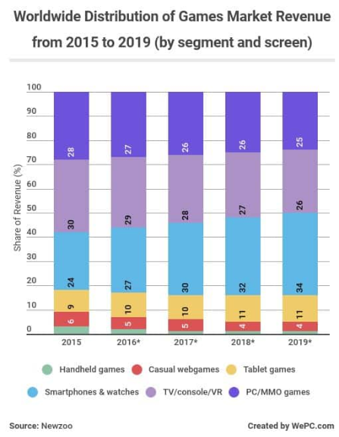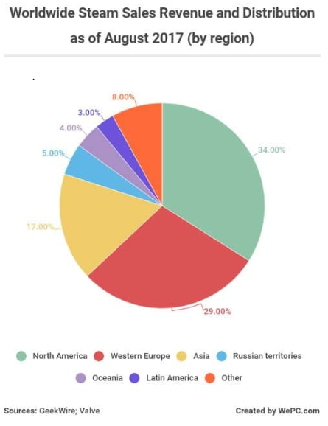

As said before the PC market is our first target at the beginning and the previous graph (Figure 3) shows that even with only PC games, the market is covered by 25% to 28%.

## Competition

Some well known games already exist with the same approach concerning the player experience. We can think about “Hitman” which combines assassination and strategy. Most of the time, games with those mechanics belong to a proper universe and proper possible interactions. Lots of games are focused on the mechanism of violence and how to make the perfect kill, “Hitman” is a good example.

In “GTA V”, released in 2013, some missions use those features around strategic planning of robbery. The player has to build his team and find as much information as possible to ease the robbery.

However our game will bring a new combination of the detective and hitman aspect that can’t be yet found on major games. The approach is for the player to be implicated much more in the puzzle, the strategy and the storytelling instead of the final gameplay of the assassination. This game will allow each and every move to have a consequence over the missions.

# Commercial & Business strategy

## Addressing the market

In the video game domain, a lot of work has to be done on the advertisement part, since the market is overcrowded of all kind of games. It is really important to invest so much from the first year because a lot in the online video game market is done thanks to comments and rankings, we have to focus on this part.

To reach our first clients, we are planning to make a campaign around youtubers and other video games actors which are very popular and can easily make us known from the community that we target.

Our typical player is a player who loves “puzzle” and strategic games. That means that the intellectual process is very important to him and therefore he is usually older than the other players who are more into blood and violence games. This is a very important point because the biggest part of our players has a salary and may be more keen to buy our DLC. Indeed, younger players often use their parents' money to buy their games. Moreover, violence and blood will be present as an important feature in the game, therefore our audience will be mostly men between 14 and 30 years old.

## Business model & source of income

The game will be mainly developed in a numeric way as customers can access them really quick from the online markets such as Steam.

The market being the computer one for the beginning, steam will be the most famous platform in order to make sales.

To offer different experiences along with different prices, the business model is oriented toward a modern and mostly used way : a 3 part business :

* Classic product : 10€
* Premium product : 20€
* DLC product (in-app purchases for more content) : 5€ each content

The amounts indicated above correspond to the amount effectively received. Therefore, it doesn’t correspond to the purchase price for the customer.

The classic product is the very basic game which will be ordered on Steam as numeric version. The premium version will allow the most dedicated gamers to pre-order and have a fully load game with bonuses and prepaid DLC.

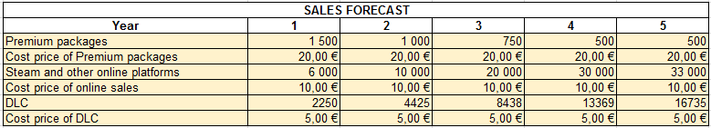

Table of sales forecast

These sales forecast numbers have been directly made upon what happened with the franchise that we compared this game to : GTA. When first released in October 1997 “GTA I” achieved the exploit of 1 million units during the first year thanks to the innovation and the growing video game market at that period

*(https://web.archive.org/web/20000226032009/http://headline.gamespot.com/news/98_11/16_vg_grand/index.html)*. Knowing that this market has evolved since, we decided to try and put a factor 100 to lower these estimations which gave a total amount around 10 000 units sold for one year. We then decided to make a repartition following the months and the changes which consist of less sales with the integration of DLC market. Considering that previous graph we can see that the DLC market is now grossly 1.5 times more important than premium packages which results in 2 250 DLC for 1500 packages.

In order to represent sales over months, we’ve decided for the first 2 years that the growth will be linear and for the last 3 years it was divided continuously.

Premium versions will be mainly sold as pre-sales, however, it is the only way for players to have a physical version, therefore some sales are still present for the next few years.

The number of games sold will raise thanks to our marketing strategy, same for DLC.

## Financing

In order to stay viable the first months and years, it is obvious that some money will have to be there at the very beginning. That is why we intend to divide our starting capital in three parts :

* A social capital provided by us which will be equal to 70k€, we can adapt this amount depending on subventions, however, we’ve preferred to make a budget without any because we can’t be sure to have some.
* A capital provided by banks in the form of loans with low interest rates, 40k€ borrowed over 5 years at a rate of 1.3%
* Pre-sales represent the biggest part of premium version sold, we’re planning on selling this version before the game is finished in order to raise some money, around 30k€.

# Financial projections & estimation

## Assumptions

The core team will be composed of 5 members. First, each member will work on his personal computer because it’s sufficient and we won’t have any office. However, the company will pay for licenses and insurances.

We’ve decided to use the starting date the date which corresponds to the release of the game on Steam and the money of pre-orders will be collected at this moment.

As none of the developers has sufficient knowledge in design creation (for the characters, images, etc…), the biggest part of it will be outsourced, same for translations and sounds of the game.

We’ve decided to put 30 % of the income to the marketing and advertising part in order to gain a lot of share from the moment the game is released. This is a “normal” rate for companies on the videogame market.

For the first 3 years, the sales increase linearly during each year in order to take into account the propagation of it. Then, we assume that it will be stabilised because the biggest part of our targeted customers already bought the game.

The amount of DLC is calculated according to the number of people who have already bought the game.

We are planning on releasing a DLC every 6 months in order to build loyalty with our players.

## Required investments

To minimize our costs during the first years, we’ll work with our own computers and without offices. The company will pay for insurance and licenses. But, as soon as, we will start hiring people, we will have to provide them the necessary equipment.

Table of amortizations

In the second year, we will need a very powerful computer to run our game in HD and to be able to test it. It will also help us doing some basic and preliminary design and sound works.

In the 4th year, we are planning on hiring a designer therefore, we need a computer for his work.

## Costs estimation

The costs for our projects have been detailed enough to think about lots of them. Corresponding to the outflows that we will have (see the Excel, or Appendix 1), composed of :

* Outsourcing, it will help doing all the small tasks that we can’t do internally such as design, sounds and translations. Indeed, in the starting team, or core team, nobody has enough capabilities to deliver a proper work in those domains. Moreover, it’s impossible to think about hiring in the first years because the cost would be higher. Outsource allows us to clearly forecast costs and to have a good work at due time and therefore to ease the development process.
* The first year, we will have to register our company into the portuguese market. This will cost us 685€ since each of the 5 core members our putting money as social capital. (https://www.lisbob.net/fr/blog/comment-creer-entreprise-societe-une-1-heure-portugal-entrepreneur)
* Rent, from the third year onwards, we’ll rent offices in Lisbon. This is important to be able to receive investors and clients.
* Insurances and licenses, the company will provide insurance for all of the computers and licenses such as the Office suite to be able to work together and Unity3D to develop the game
* Company creation is the amount that we need to pay to create our company officially
* Staff members & social security contribution, see below
* Taxes
* Taxes on result
* Advertising, since it is the most important part we’ve decided to fix a budget of 30% of the income.
* Loans repayment
* Other costs such as office equipment

## Human resources

Payroll table per month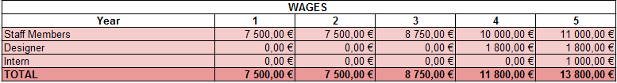

This table only represents the wages of each member of the team per month. We have to take into account the amount of social security which is 23.75% of the wages in Portugal.

Our human resources strategy is to increase our salary as soon as we have profits. We will hire a designer in order to reduce our outsource costs and to prepare the future of the company. The intern who will hopefully be hired at the end will be responsible of the DLC development in order to free the staff members who will work on a new game.

We’ve chosen to pay everybody on a 12-months basis without bonus. However, depending on the income and profits, we can modify this policy.

## Cash flow estimates

## 

The initial investment has been calculated in order not be below 0 at the minimum.

## Financing KPIs

Since we will ask for loans instead of investors mainly because interest rates are lower, our main KPIs is NPV. Indeed, ROI doesn’t make any sense since we’re lending money from banks over 5 years.

Our calculated NPV is 42k€ at the end of the 5th year, this is more than the amount lent.

## Future of the company

As we can see on the cash flow chart, at the end of the 5th year, the cash flow is at the point of the beginning. At this point, the bank loan is fully reimbursed, we’re independent from any other actors. We’ve hired an intern, which, hopefully, at term will be hired as one of our team, his role is mainly to be responsible of the DLC from the game and to correct small remaining bugs. Therefore the core team and the designer can be fully dedicated to the development of another game. And we have physical offices and equipment. It was important for us to reach this point. Indeed, this allows a lot of possibilities.

We can either work on another game with the same amount of money than the first one, but since we have more experience and we’ve hired more people we’ll have less costs and we can foresee more sells because our first game was a success. Otherwise, we can borrow money to hire developers or outsource some parts of the developing process. By doing so, we’ll be able to make a bigger game for instance in 3D.

We can also work on developing our game on other platforms (PS4, Xbox, …) in order to improve our passive revenue. However, it’ll maybe required a lot of outsourcing depending on the team capacities.

To develop the point about another game, we’re a team of passionate gamers. Our aim is not to stop after the first game and just live from its revenue. After the first 5 years, we are financially independent. We can take back our initial social capital or keep it in the company.

To develop the second game, we are more credible since our first game was a success, so banks and investors will be more willing to lend us money. We should always prefer a bank loans since interest rates are way lower than what investors may expect, however, banks are less willing to borrow huge amounts. So, we can use both ways, in order to have as much money as possible and hire more developers.

# Conclusion

Based on our market analysis, cost estimations and, on our somewhat conservative sales predictions, its safe to say that this is a feasible project.

There is a lot of money to be made in the PC video game industry and for this reason, it’s a very competitive market with everyone wanting to take a piece of the cake.

For this reason, in order to stand out, our company needs to have something that most competitors don’t, that could be our dedicated and committed team with their passion for video games. However, dedication alone doesn’t keep a company afloat, to further stand out we choose to have a premium edition of our game to cater to the die hard fans of the genre and to have DLC content to build loyalty and to bring a continuous revenue to the company.

Like every other projects, this one isn’t perfect either, so we manage to observe some weaknesses and threats as well, like the possibility of having even less sales than expected, using Steam as the main, and possibly, the only online sales platform can make us dependent on them and therefore vulnerable, nevertheless Steam is vastly the mostly common used platform for PC gaming and will allow for a more effective marketing campaign. There is also the possibility of some issues related to the game design, bugs, etc. That can postpone the release of the game and that will translate into more costs and a delay on the sales and profit. But as long as we keep those risks in mind, we should be able to adapt ourselves to those hazards.

To try to bridge this gap, in the future we aim to continue improving this game and its levels with periodic updates, develop this and future games not only for PC, but for other platforms as well, mainly ps4 and mobile. This way the company can diversify its markets and stay competitive in an always changing industry.

# Appendix

Appendix 1 : Total operating costs over the years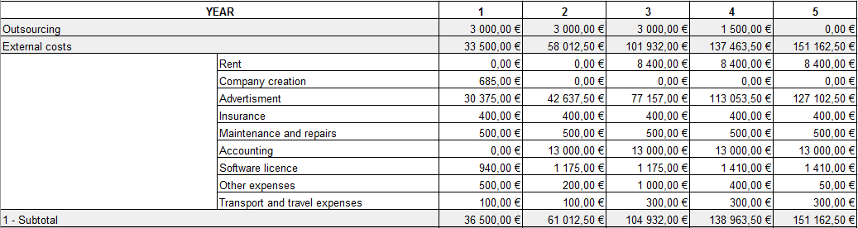

Source for the cost of company creation : <https://www.lisbob.net/fr/blog/comment-creer-entreprise-societe-une-1-heure-portugal-entrepreneur>